Assignment 3

Problem statement: Employee Leave Management System

Group details:

Name | Roll no
Sougata Patra | 25
Puja Sarkar | 10
Arpan Mondal | 2

Data flow diagrams:

DFD L0:
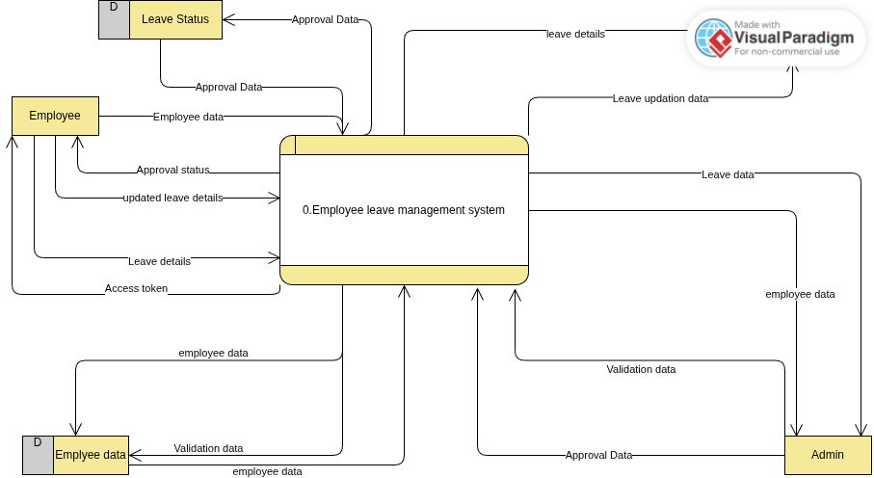
DFD L1:
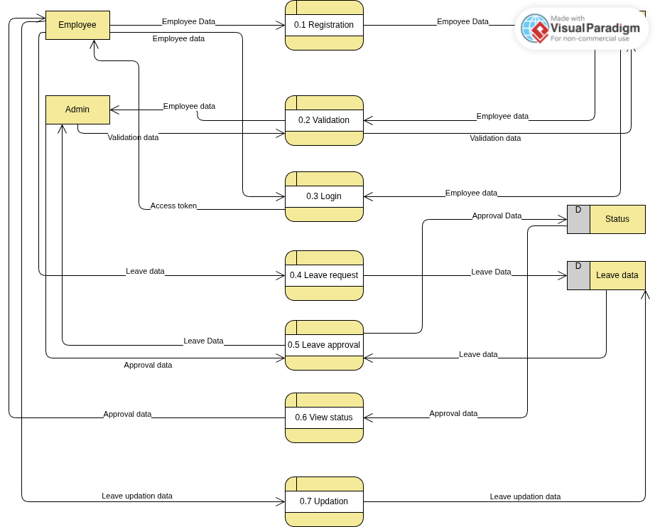

DFD L2:
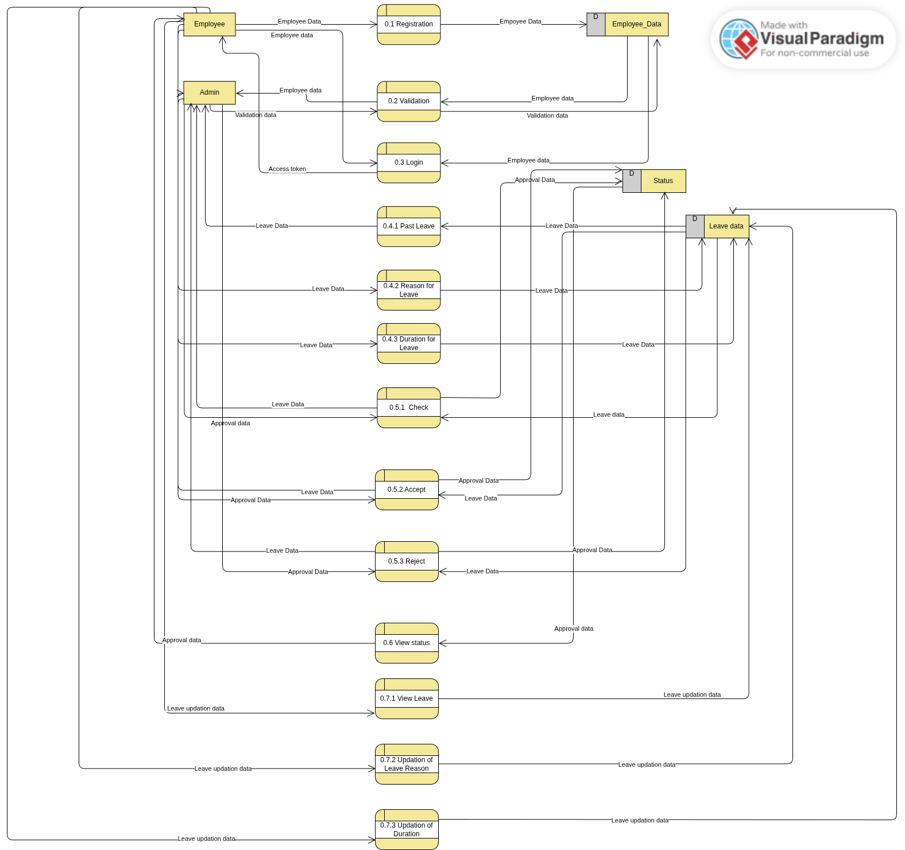

Structure chart:
